**EXPERIMENT NO:-1:**

**Investigating the significance of Characteristic Impedance (Zo), and**

**Propagation Constant (γ)of a Transmission Line using the following**

**parameters**

**a) Resistance b) Capacitance c) Inductance d) Conductance**

**PROGRAM:**

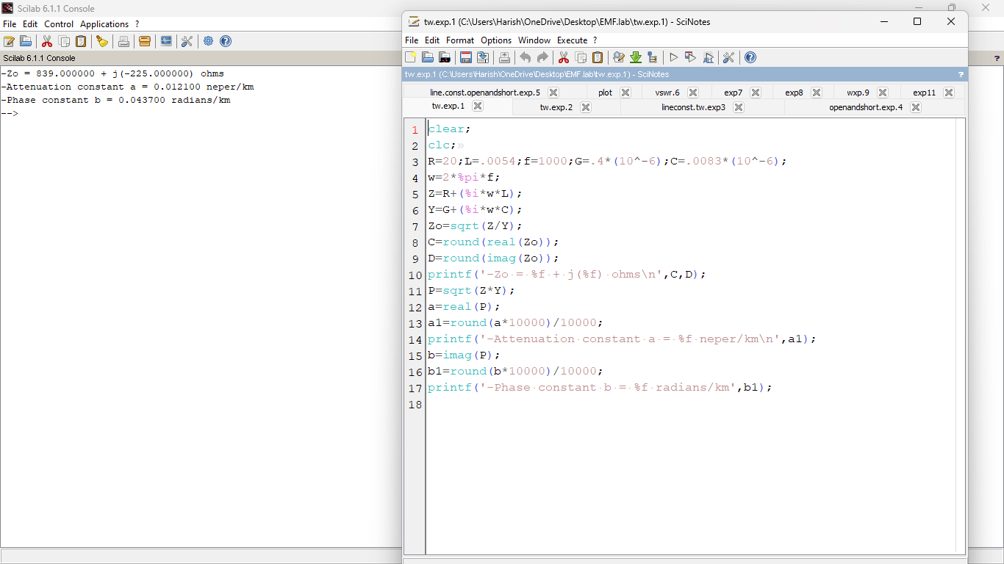

**OUTPUT:**



**EXPERIMENT NO:-2:**

**Estimation of Primary Constants (R,L,G &amp;C) from Secondary Constants (Zo&amp; γ )of an open wire transmission line**

**PROGRAM:**

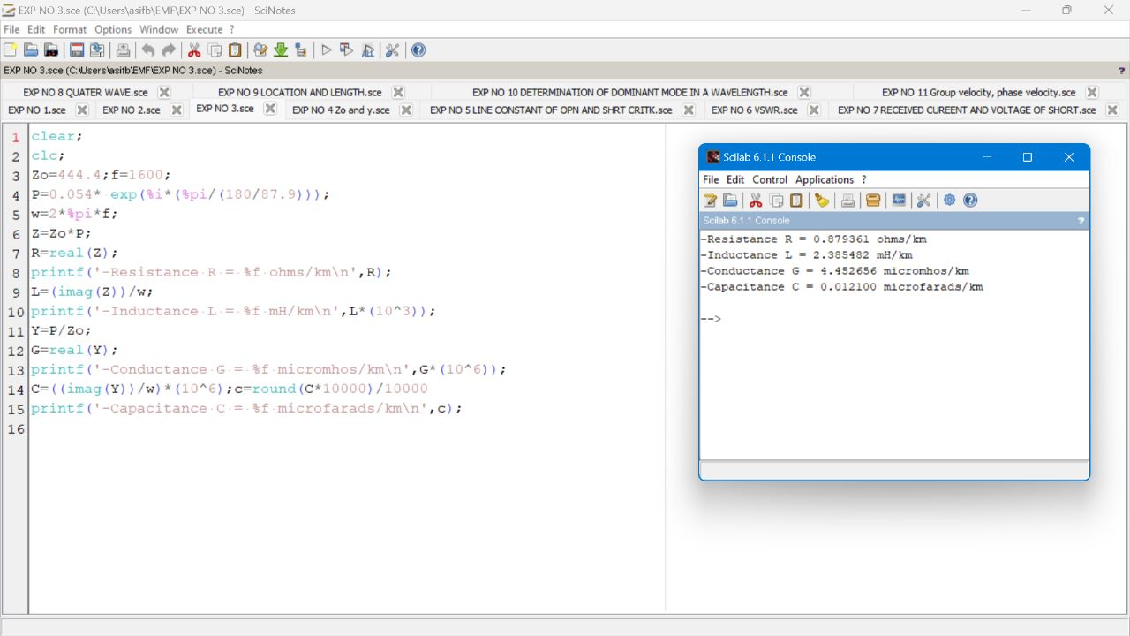

**OUTPUT:**



**EXPERIMENT NO:-3:**

**Examining the impact of open and short circuited loads on**

**a)Characteristic Impedance b) Propagation Constant**

**PROGRAM:**

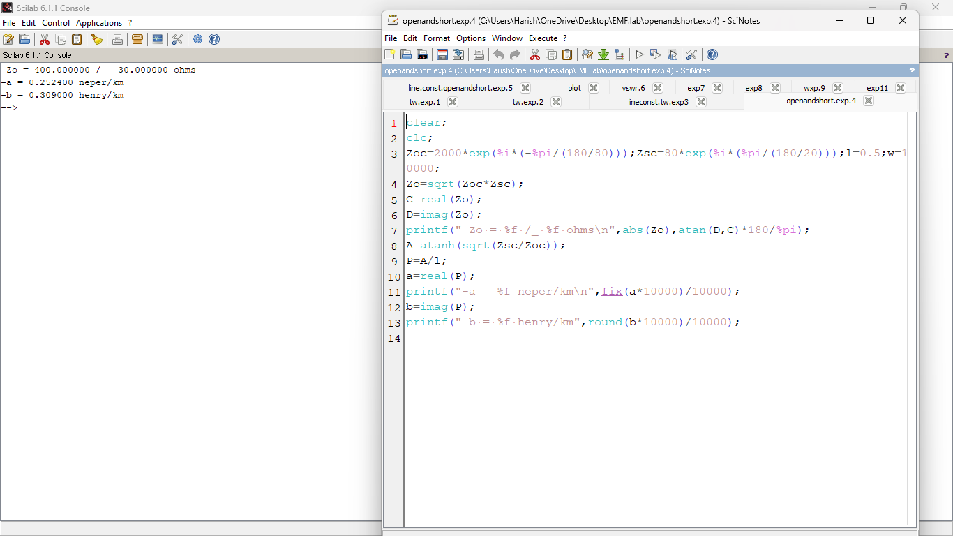

**OUTPUT:**



**EXPERIMENT NO:-4:**

**Evaluation of current and voltage of a short circuited Lossless transmission**

**line at the receiving end**

**PROGRAM:**

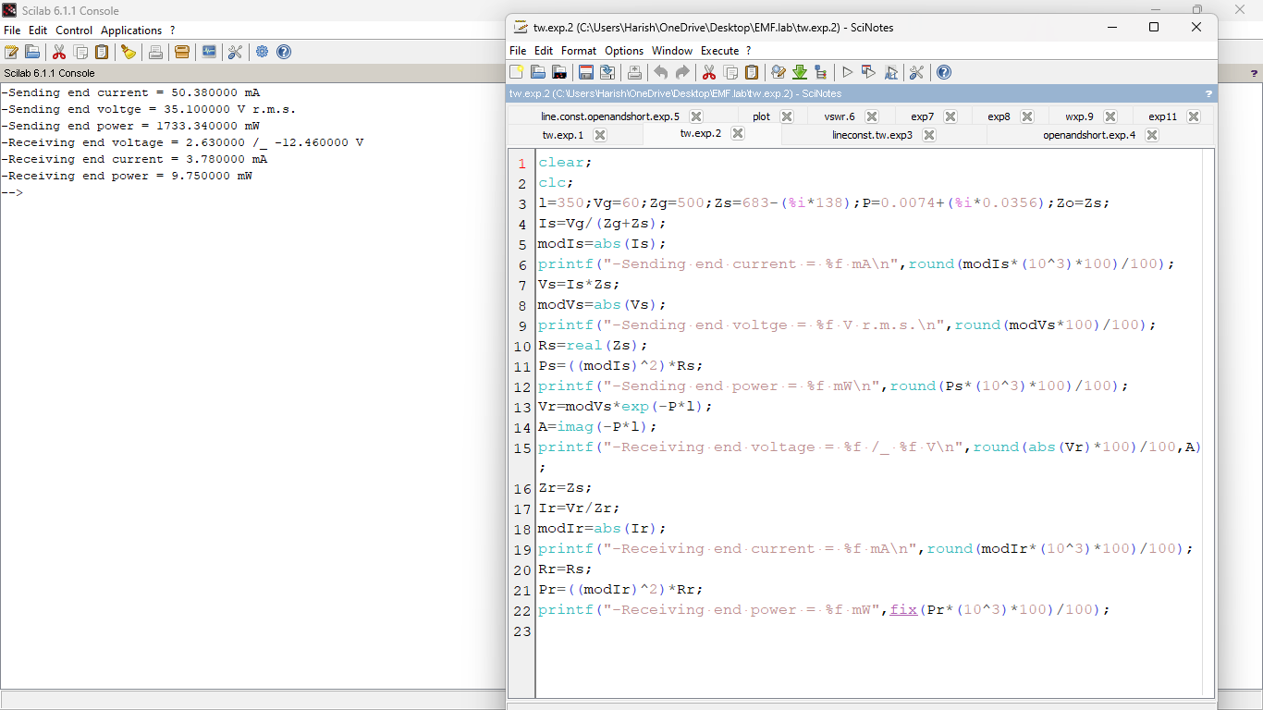

**OUTPUT:**



**EXPERIMENT NO:-5:**

**Analysis of SWR (Standing Wave Ratio) pattern in High Frequency**

**Transmission Lines by varying**

**a) load impedance b) characteristic impedance**

**PROGRAM:**

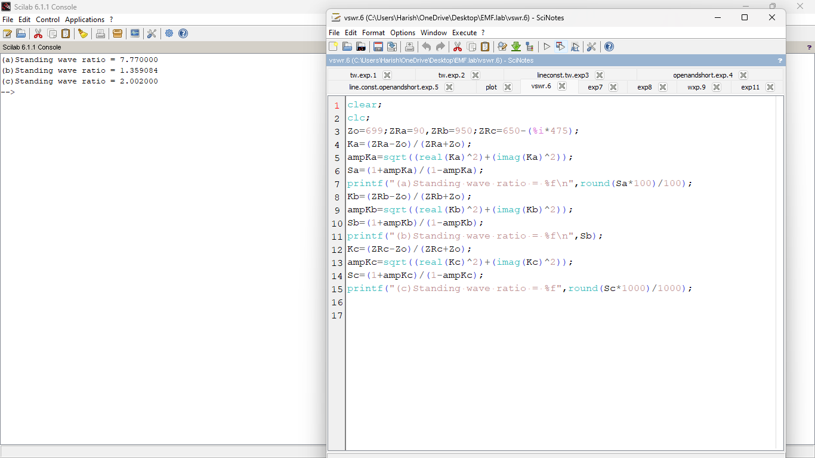

**OUTPUT:**



**EXPERIMENT NO:-6:**

**Exploration of the relationship between SWR (Standing Wave Ratio) and the**

**position of Voltage minima nearest to the load by varying magnitude of**

**reflection coefficient K**

**PROGRAM:**

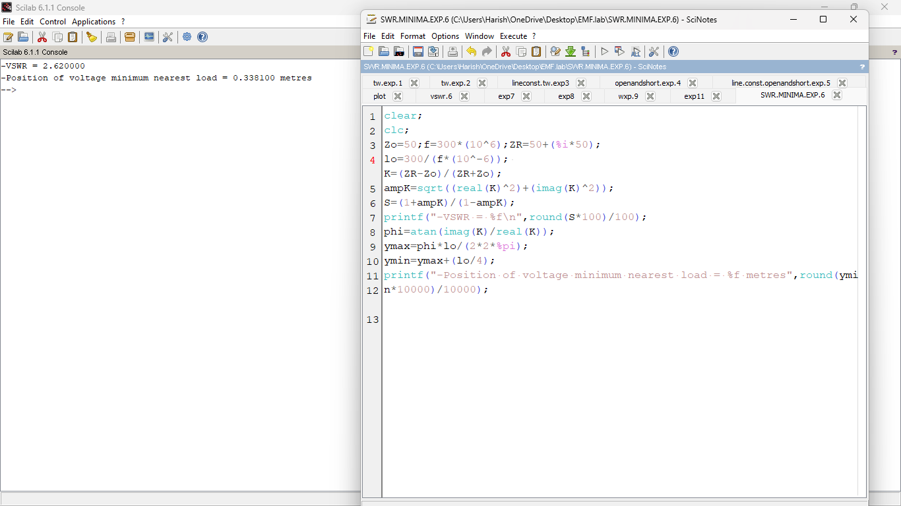

**OUTPUT:**



**EXPERIMENT NO:-7:**

**Designing a Quarter wave transformer for impedance matching for the**

**following parameters**

1. **frequency b) input impedance c) characteristic impedance**

**PROGRAM:**

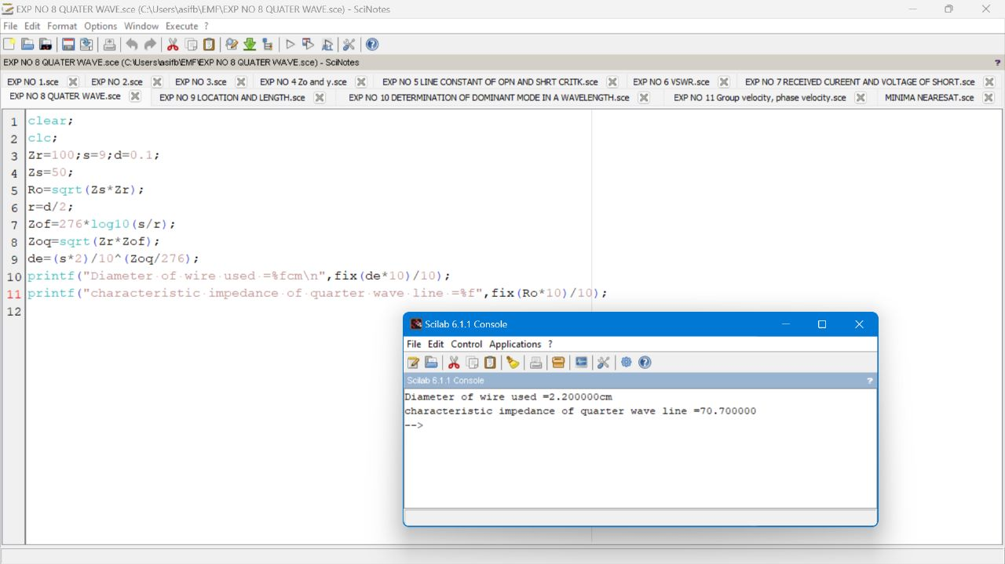

**OUTPUT:**



**EXPERIMENT NO:-8:**

**Strategize impedance matching with Short Circuited Stub for a given**

**characteristic impedance and load impedance through the measurement of**

1. **Location of the stub b) Length of the stub**

**PROGRAM:**

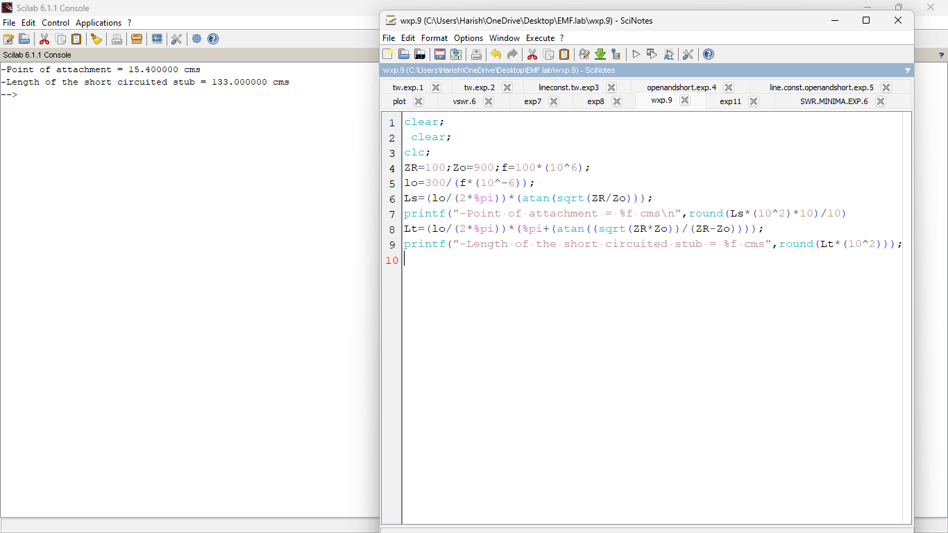

**OUTPUT:**



**EXPERIMENT NO:-9:**

**Analysis of Electromagnetic Waves across the two parallel plates by**

**estimating the following**

1. **Critical Wavelength b) Guide Wavelength**

**PROGRAM:**

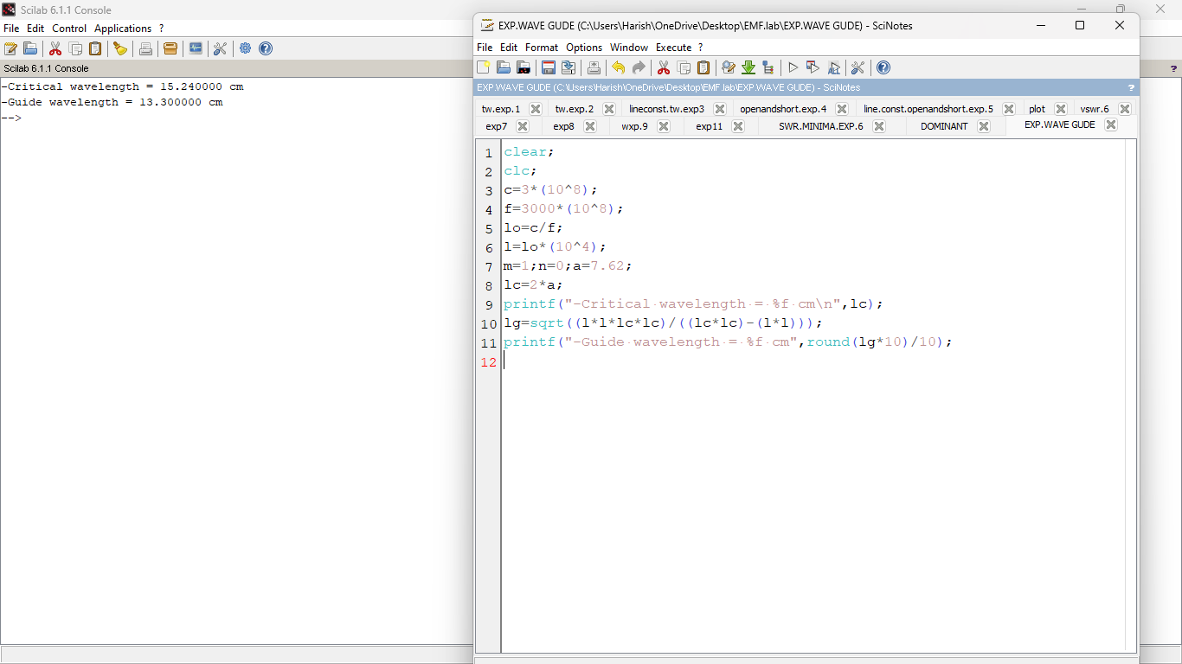

**OUTPUT:**



**EXPERIMENT NO:-10:**

**Determination of Dominant mode of parallel plate waveguides by examining**

**the TE and TM modes**

**PROGRAM:**

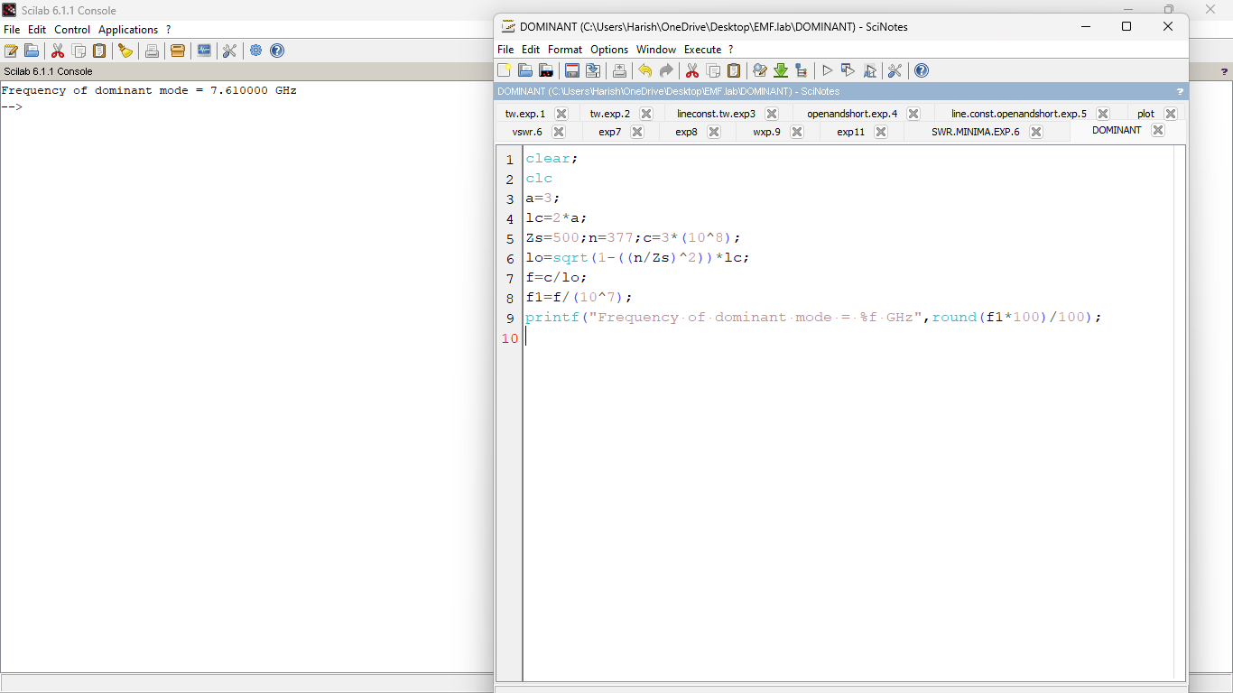

**OUTPUT:**



**EXPERIMENT NO:-11:**

**Calculation of Group velocity, Phase velocity and phase constant of EM**

**waves in rectangular waveguides**

**PROGRAM:**

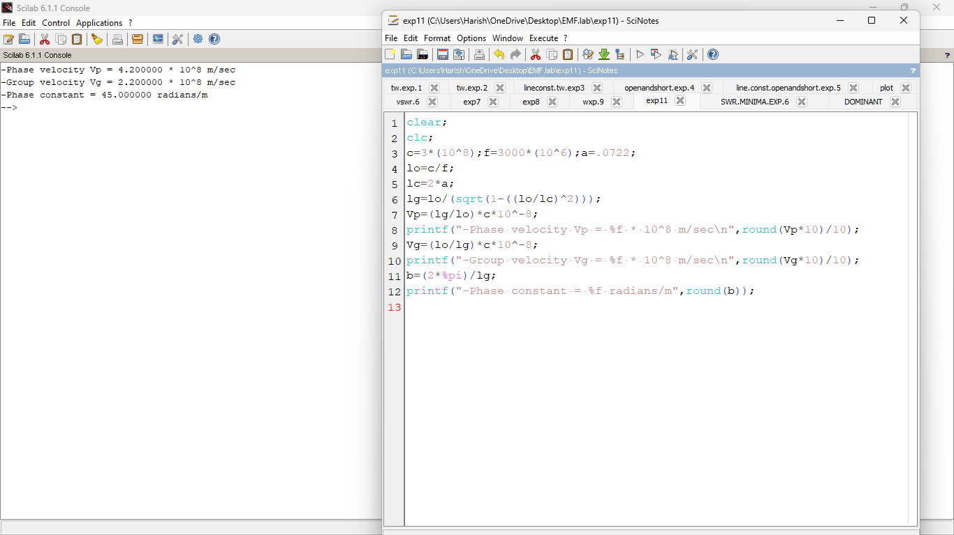

**OUTPUT:**



**EXPERIMENT NO:-12:**

**Examining the propagation characteristics of circular waveguide in terms of**

**a)Cutoff wavelength b) Guide wavelength c) characteristic impedance**

**PROGRAM:**

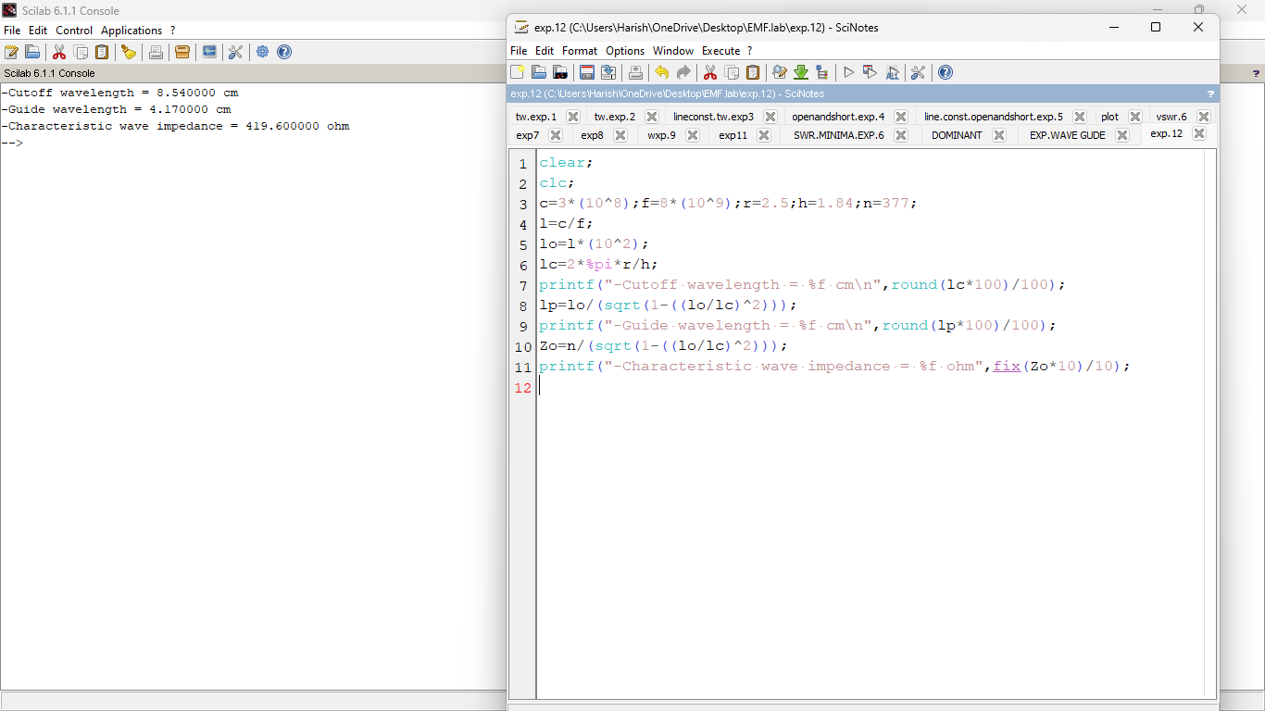

**OUTPUT:**



**EXPERIMENT NO:-13:**

**Inference of Q Factor of Rectangular Cavity Resonator for TE101 mode**

**with the following inputs**

1. **Dimension a in x axis b) Dimension b in y axis c) Dimension p in z axis**

**PROGRAM:**

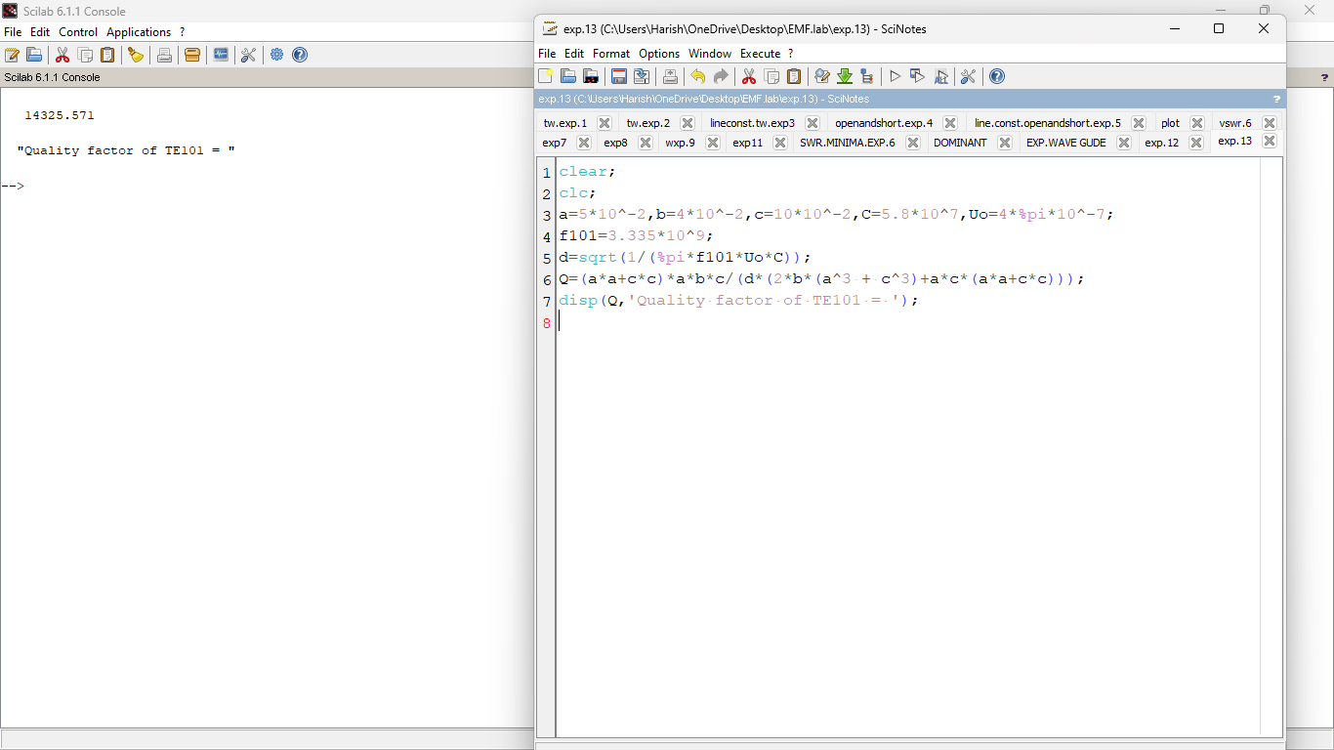

**OUTPUT:**



**EXPERIMENT NO:-14:**

**Computation of Resonant Frequency of Rectangular Cavity Resonator for**

**a)Transverse Electric mode b)Transverse Magnetic mode**

**PROGRAM:**

**a)Transverse Electric mode**

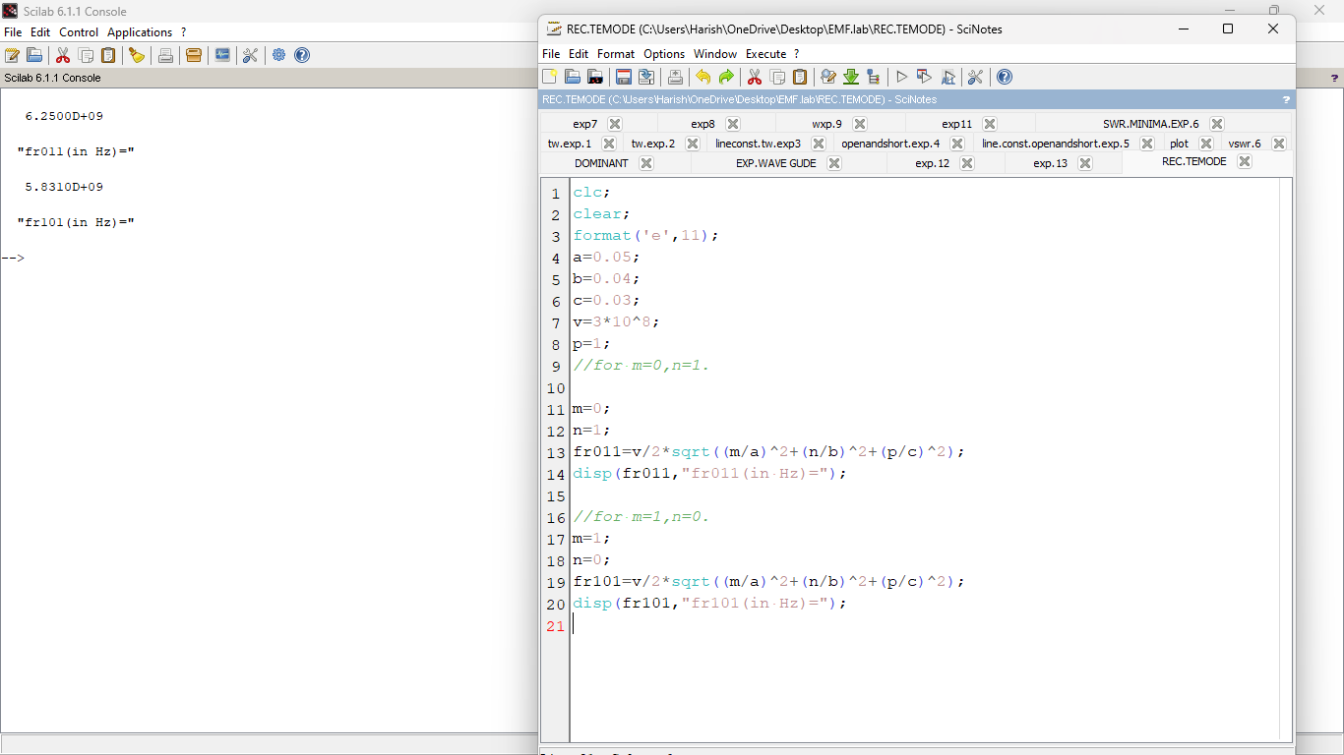

**OUTPUT:**



**b)Transverse Magnetic mode:**

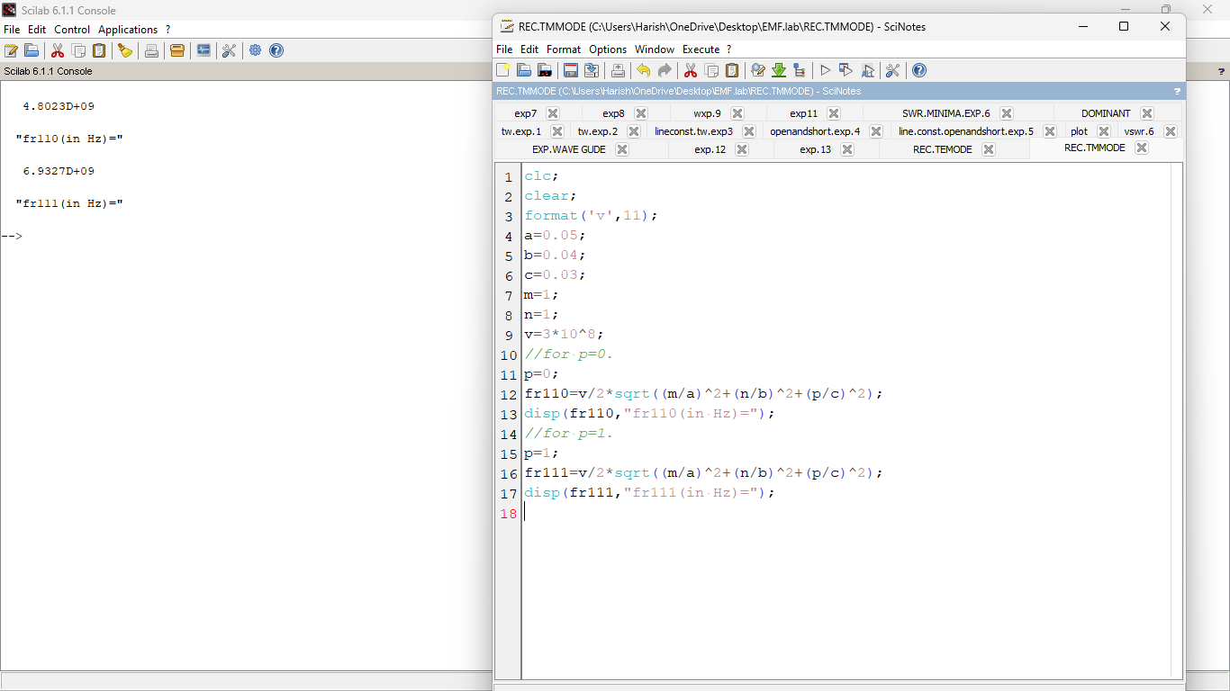

**OUTPUT:**



**EXPERIMENT NO:-15:**

**Estimation of Resonant Frequency in a Cylindrical Cavity Resonator for**

**a)Transverse Electric mode b)Transverse Magnetic mode**

**PROGRAM:**

**a)Transverse Electric mode :**

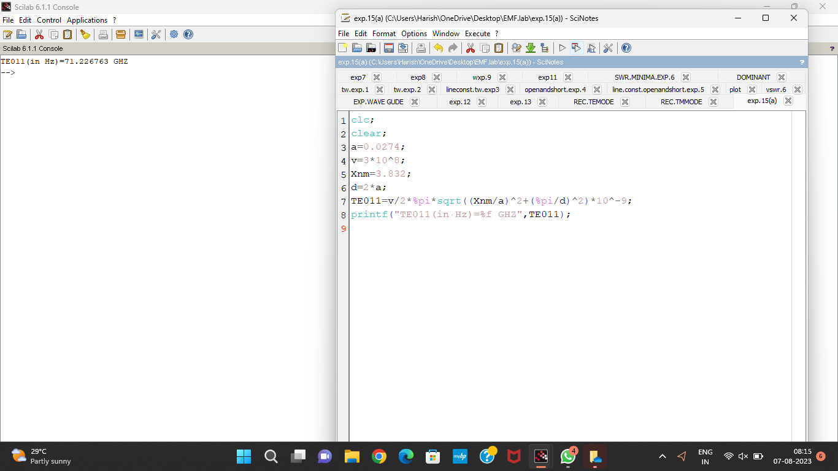

**OUTPUT:**



**b)Transverse Magnetic mode:**

**PROGRAM:**

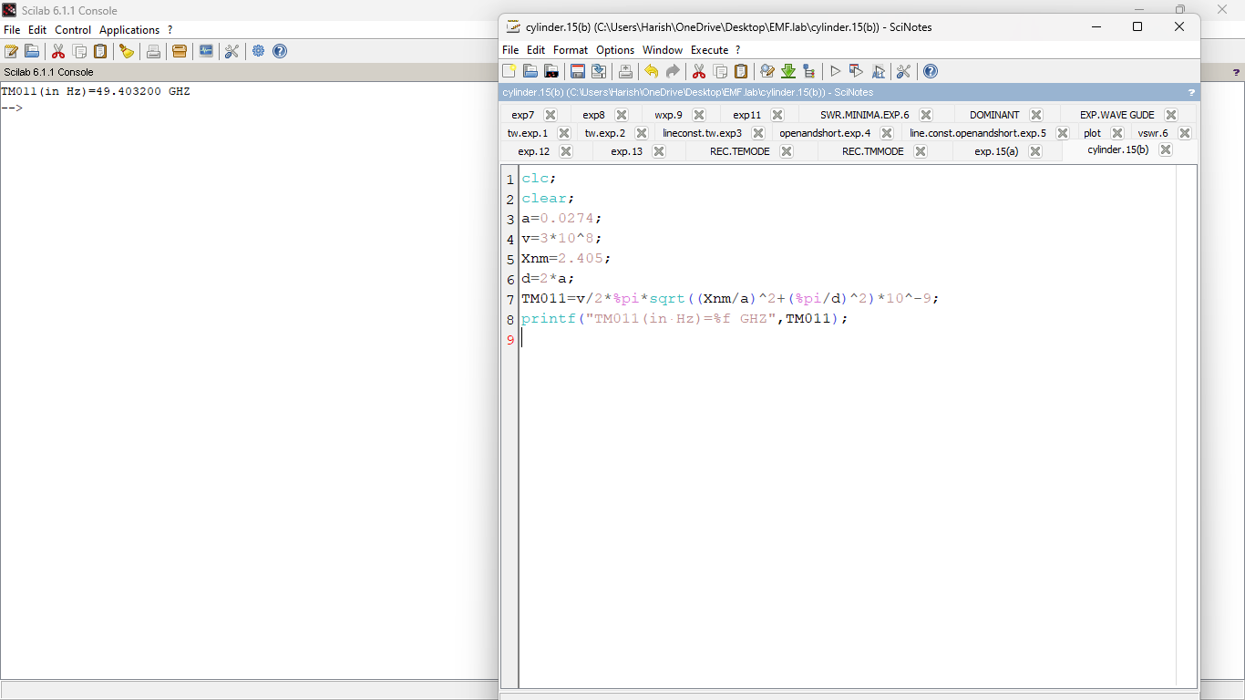

**OUTPUT:**

